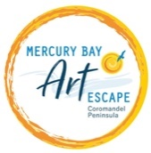

New Artist or Group Application form 2023

Thank you for your interest in becoming a member artist. Please complete this form and return to admin@mercurybayartescape.com by 14 August 2022.

Artist name or Group name
Group contact
Address
Email
Phone
Mobile
Website
Artist Facebook address
Artist Instagram address
Mediums (e.g. Painting, sculpture, photography etc)
What is your connection to the Mercury Bay region? (i.e. Live, work, have property in the area or other connection to the area)
Artist Statement
Max 100 words

Tell us a little bit about
yourself/group and your art or attach artist CV
Tell us a about your studio/display space
Groups: When and where your group meets
Other comments

Please email to admin@mercurybayartescape.com 6-8 images
(minimum 300 dpi max size 1 MB, no watermarks) of your recent artwork.

When this has been returned the Selection Panel will acknowledge receipt and be in touch with you to arrange a visit to your studio by end of August. Further membership guidelines will be discussed then and decision advised by 10 September 2022.

If you have any queries do not hesitate to contact Monique Rush
monique_rush@artlover.com Phone 021 827 600 Evenings

